Seminars are regularly organized by the PG students of Botany, Govt. Lohia College, Churu under the convenership of
Dr. Sher Mohammed, Head, Department of Botany
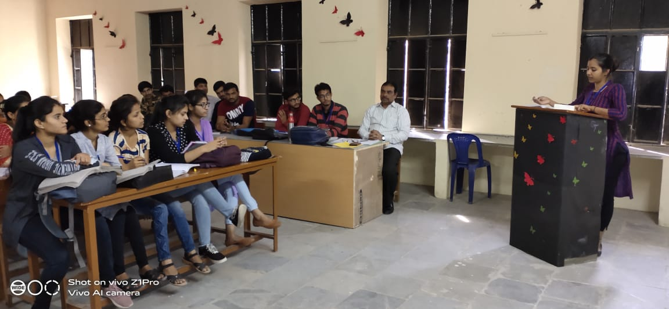

Seminar Photo
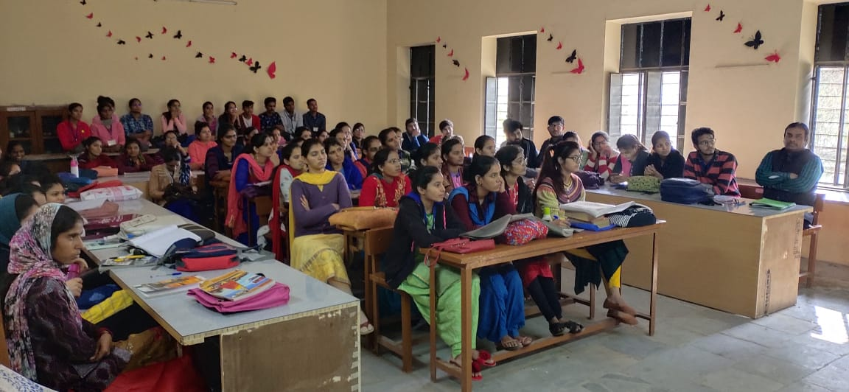

Seminar Photo
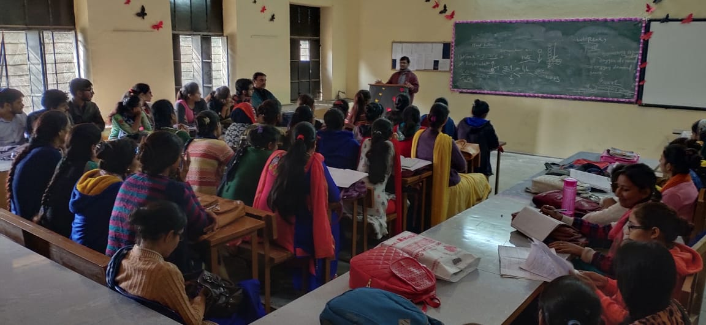

Seminar Photo
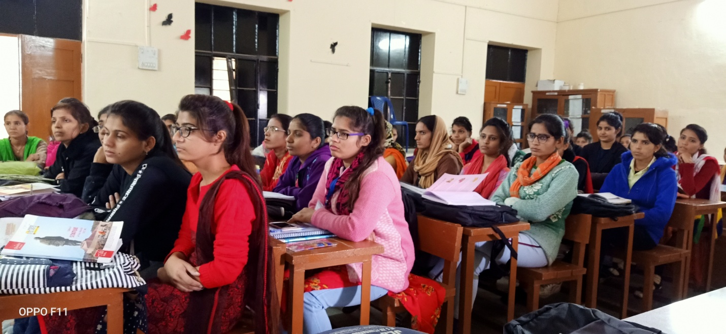

Seminar Photo
